**Safe Sport Day: 8th August 2024**

**Social Media Guide**

Join the campaign on Safe Sport Day and help us raise awareness of the importance of safe sport for every child.

**Last year, so many of you championed Safe Sport Day across your channels which was fantastic to see. In 2024, we’re setting out to make an even bigger impact!**

**Key Messaging:**

**Safe Sport Day is a reminder to make sport safe EVERY day.**

**Call to Action: “**We've committed to keeping children safe in sport every day. Make that commitment too and join #TeamSafeSport!”

**What you can do before Safe Sport Day:**

1. Create a social media **countdown** leading up to Safe Sport Day.
2. **Tease the announcement** of your latest safeguarding success or initiative.
3. **Learn more** about the International Safeguards at [SafeInSport.org](http://www.safeinsport.org).

**What you can do on Safe Sport Day:**

1. Use August 8th to **announce your latest safeguarding success or initiative**. Share your **solutions and/or what you’re trying to achieve**.
2. Identify a safeguarding ambassador from your organisation to provide a video you can post on Safe Sport Day. Suggested prompt: **Celebrate what makes you feel safe in sport and why it is important.**
3. If you haven’t done it, **take the Safe Sport Pledge** [**here**](https://safeinsport.org/take-the-pledge/) **and** **then share**.
4. Invite your athletes to **post on their own accounts** about safeguarding and Safe Sport Day.

**Graphics:** We have created [this graphic](https://culture.safeinsport.org/resource-uploads/Safe%20Sport%20Day%202024%20English.png) for you to adapt and use.

**Best Practice Guidance (Facebook, Twitter, Instagram, LinkedIn)**

**Always include these hashtags:**

**#SafeSportDay + #TeamSafeSport**

**Tag:**

Facebook and X (Twitter): **@SafeInSports**

Instagram: **@internationalsafeguards**

LinkedIn:**@international safeguards for children in sport**

**Like, Share, Retweet, Repost:**

**Facebook:** Follow page, and like and share posts: <https://www.facebook.com/SafeinSports>

**X (Twitter):** Follow, like, and retweet: <https://twitter.com/SafeinSports>

**Instagram:** Follow, like, and repost: <https://www.instagram.com/internationalsafeguards/>

**LinkedIn:** Follow, like, and repost:<https://www.linkedin.com/company/international-safeguards-for-children-in-sport/>

**Photos and Videos**

Video is key, especially video of your athletes sharing their thoughts about safeguarding!

**When photographing or filming:**

* 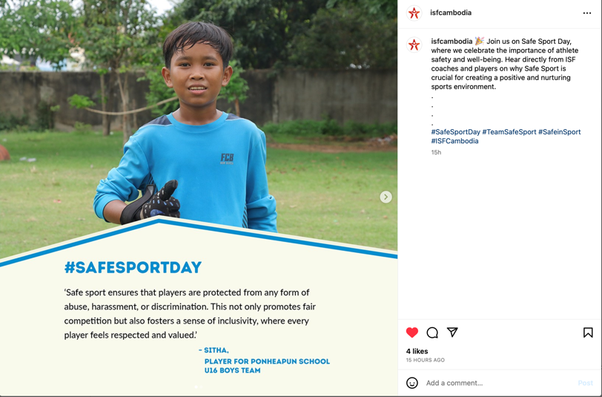**Lighting.** Natural light is best! Film outside or set up near a window. If that is not an option, try to get it as bright as possible.
* **Get creative and have fun!** Film or take a photo on your field of play.
* **Get close.** Instead of “zooming in”, move in as close to your subject as you can.
* **Get permission** before sharing any photo or video, especially for children 17 and under (see additional guidance below).

**Guidance Around Images and Films of Children**

If you involve children in the campaign, it is really important you get their **informed consent** before using photos or videos of them. *Informed consent* means giving permission in **full knowledge** of the possible consequences.

Click [here](https://culture.safeinsport.org/resource-uploads/Guidance%20on%20images%20of%20children%20for%20SSD2024.docx) for more guidance and a sample release form.